PIZZA SALES SQL QUERIES
A. KPI’S
1. Total Revenue
SELECT SUM(total_price) AS total_revenue FROM pizza_sales;
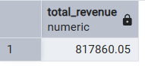
2. Average Order Value
SELECT SUM(total_price) / COUNT(DISTINCT order_id) AS avg_order_value FROM pizza_sales
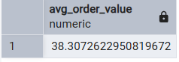
3. Total Pizzas Sold
SELECT SUM(quantity) AS total_pizzas_sold FROM pizza_sales
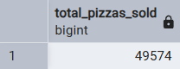
4. Total Orders Placed
SELECT COUNT(DISTINCT order_id) AS total_orders FROM pizza_sales
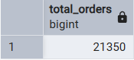
5. Average Pizzas Per Order
SELECT CAST(CAST(SUM(quantity) AS DECIMAL(10,2)) /
CAST(COUNT(DISTINCT order_id) AS DECIMAL (10,2))
AS DECIMAL(10,2)) AS avg_pizzas_per_order FROM pizza_sales
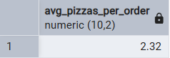

6. Daily Trend
SELECT to_char(order_date, 'Day') AS order_day,
COUNT(DISTINCT order_id) AS total_orders FROM pizza_sales
GROUP BY to_char(order_date, 'Day')
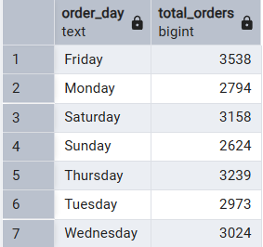

7. Hourly Trend
SELECT to_char(order_time, 'HH24') AS order_hours,
COUNT(DISTINCT order_id) AS total_orders FROM pizza_sales
GROUP BY to_char(order_time, 'HH24')
ORDER BY to_char(order_time, 'HH24')
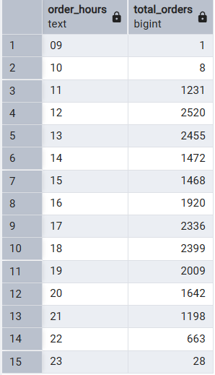

8. Pizza Sales by Category
SELECT pizza_category, SUM(total_price) AS total_sales, CAST(sum(total_price)/
(SELECT SUM(total_price) FROM pizza_sales)*100 AS DECIMAL(10,0)) AS PCT
FROM pizza_sales
GROUP BY pizza_category
ORDER BY pct DESC
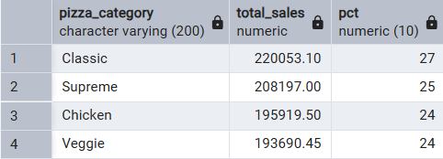
9. Pizza Sales by Size
SELECT pizza_size, SUM(total_price) AS total_sales, CAST(sum(total_price)/
(SELECT SUM(total_price) FROM pizza_sales)*100 AS DECIMAL(10,0)) AS PCT
FROM pizza_sales
GROUP BY pizza_size
ORDER BY pct DESC
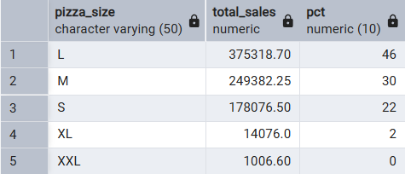

10. Total Pizzas Sold by Category
SELECT pizza_category, SUM(quantity) AS total_sold FROM pizza_sales
GROUP BY pizza_category
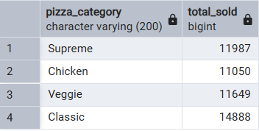

11. Top 5 Best Selling Pizzas
SELECT pizza_name, SUM(quantity) AS total_sold FROM pizza_sales
GROUP BY pizza_name
ORDER BY SUM(quantity) DESC
LIMIT 5;
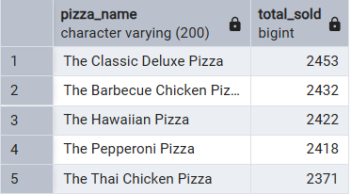

12. Worst 5 Selling Pizzas
SELECT pizza_name, SUM(quantity) AS total_sold FROM pizza_sales
GROUP BY pizza_name
ORDER BY SUM(quantity)
LIMIT 5
